Roll No-12

M.sc. 3rd semester

Date of Assignment-02/12/2020

Date of Submission-08/12/2020

**Experiment No -08**

**Topic**- Tracing the power curve for Normal distribution with unknown mean and variance

**Problem** – Consider the following example of size 11 from  where  and  both are unknown. The sample values are 5.2, 10.8, 7.1, 16.4, 12.5, 12, 10.3, 10.0, 12.7, 9.7, 10.5

Obtain the most powerful similar regions for testing  against

1. 
2. 
3. 

Also, draw the power curve for each of the cases considering the level of significance as 

**Theory and Calculation**-

i) The CR for testing  against  is given by



S can be computed from the sample values and to obtain the values of  ,we use the following R-command.

alfa=0.05

n = 11

t_tab_1=qt(1-alfa,n-1)

t_tab_1=qt(0.95,10)

t_tab_1

t_tab1= 1.812461

To find out the value of S, we use the following R-program

sv = c(5.2,10.8,7.1,15.4,12.5,12,10.3,10,12.7,9.7,10.5)

variance_sv = var(sv)

variance_sv

sqs = sqrt(variance_sv)

sqs

sqs=2.751826

To obtain the CR, we use the following R-command

sr_1 = 11+(sqs*t_tab_1)/(sqrt(n))

sr_1

 sr_1= 11.99752

The CR is given by



Now, the power of the test is given by















Where  follows student’s t-distribution with (n-1) df.

Now, to draw the power curve we construct the following table considering different values of 

**TABLE 1**

|  | **mu_1** | **power_1** |
| --- | --- | --- |
|  |  |  |
| **1** | 11.5 | 0.1270818 |
| **2** | 11.6 | 0.1507847 |
| **3** | 11.7 | 0.1777487 |
| **4** | 11.8 | 0.2080664 |
| **5** | 11.9 | 0.2417317 |
| **6** | 12.0 | 0.2786215 |
| **7** | 12.1 | 0.3184837 |
| **8** | 12.2 | 0.3609342 |
| **9** | 12.3 | 0.4054635 |
| **10** | 12.4 | 0.4514549 |
| **11** | 12.5 | 0.4982127 |
| **12** | 12.6 | 0.5449989 |
| **13** | 12.7 | 0.5910740 |
| **14** | 12.8 | 0.6357376 |
| **15** | 12.9 | 0.6783660 |
| **16** | 13.0 | 0.7184407 |
| **17** | 13.1 | 0.7555676 |
| **18** | 13.2 | 0.7894846 |
| **19** | 13.3 | 0.8200591 |
| **20** | 13.4 | 0.8472765 |
| **21** | 13.5 | 0.8712228 |
| **22** | 13.6 | 0.8920630 |
| **23** | 13.7 | 0.9100195 |
| **24** | 13.8 | 0.9253507 |
| **25** | 13.9 | 0.9383330 |
| **26** | 14.0 | 0.9492454 |
| **27** | 14.1 | 0.9583579 |
| **28** | 14.2 | 0.9659237 |
| **29** | 14.3 | 0.9721739 |
| **30** | 14.4 | 0.9773153 |

**Programming in R for case 1-**

library('ggplot2')

alfa = 0.05

n = 11

t_tab_1 = qt(1-alfa, n-1)

t_tab_1

#To find out the value of similar region, we use the following R-Program

sv = c(5.2,10.8,7.1,15.4,12.5,12,10.3,10,12.7,9.7,10.5)

variance_sv = var(sv)

variance_sv

sqs = sqrt(variance_sv)

sqs

sr_1 = 11+(sqs*t_tab_1)/(sqrt(n))

sr_1

#To find the power curve

n_1 = 11

a = sqs

mu_1 = seq(from=11.5, by=0.1, length.out=30)

mu_1

power_1 = mat.or.vec(30,1)

for(i in 1:30){

power_1[i] = 1-pt((t_tab_1-(((mu_1[i]-n_1)*sqrt(n))/a)), n-1)

}

power_1

Table = data.frame(mu_1, power_1)

Table

View(Table)

ggplot(data=Table,mapping=aes(x=mu_1,y=power_1))+geom_point()+geom_line()

data.frame(mu_1)

data.frame(power_1)

**Power curve by using ggplot 2**

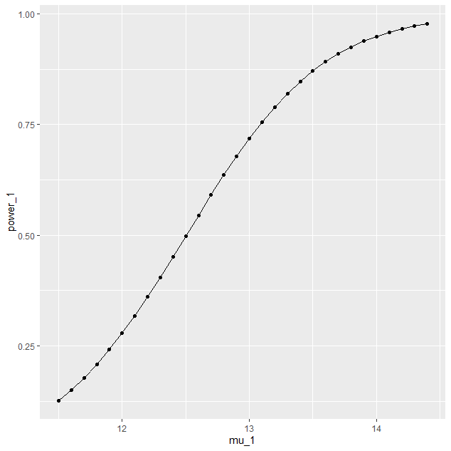

**Power curve generated by using Tableau**

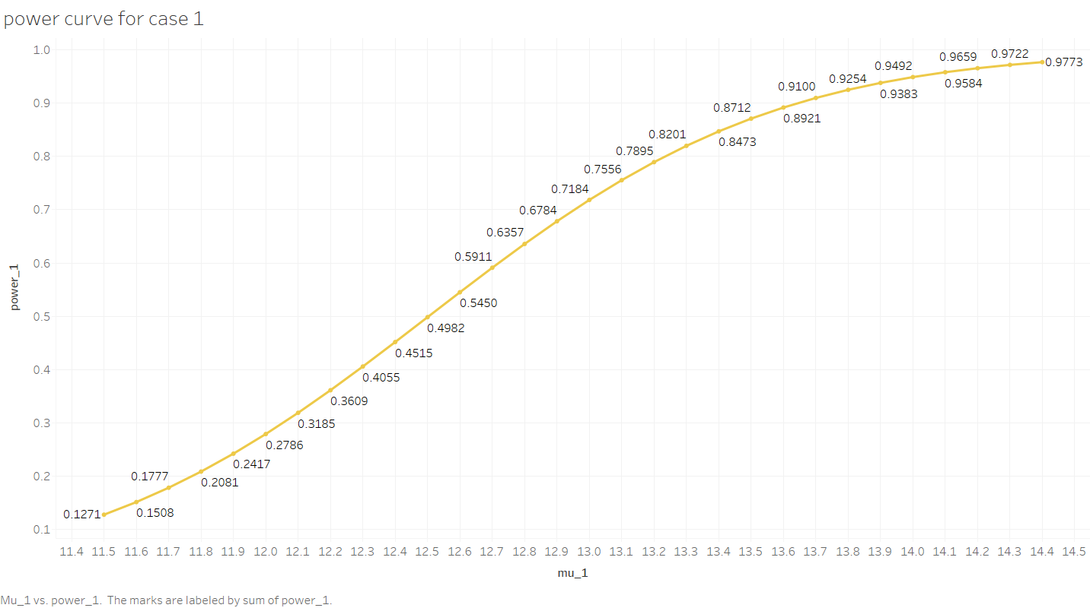

ii) The CR for testing  against  is given by



S can be computed from the sample values and to obtain the values of (-) ,we use the following R-command.

alfa = 0.05

n = 11

t_tab_2 = qt(alfa, n-1)

t_tab_2

t_tab2= -1.812461

To find out the value of S, we use the following R-program

sv = c(5.2,10.8,7.1,15.4,12.5,12,10.3,10,12.7,9.7,10.5)

variance_sv = var(sv)

variance_sv

sqs = sqrt(variance_sv)

sqs

sqs= 2.751826

To obtain the CR, we use the following R-command

sr_2 = 11+(sqs*t_tab_2)/(sqrt(n))

sr_2

 sr_2 = 9.496189

The CR is given by



Now, the power of the test is given by













Where  follows student’s t-distribution with (n-1) df.

Now, to draw the power curve we construct the following table considering different values of 

**TABLE 2**

|  | **mu_2** | **power_2** |
| --- | --- | --- |
|  |  |  |
| **1** | 8.0 | 0.94924537 |
| **2** | 8.1 | 0.93833301 |
| **3** | 8.2 | 0.92535070 |
| **4** | 8.3 | 0.91001947 |
| **5** | 8.4 | 0.89206302 |
| **6** | 8.5 | 0.87122282 |
| **7** | 8.6 | 0.84727654 |
| **8** | 8.7 | 0.82005907 |
| **9** | 8.8 | 0.78948456 |
| **10** | 8.9 | 0.75556758 |
| **11** | 9.0 | 0.71844072 |
| **12** | 9.1 | 0.67836601 |
| **13** | 9.2 | 0.63573760 |
| **14** | 9.3 | 0.59107395 |
| **15** | 9.4 | 0.54499892 |
| **16** | 9.5 | 0.49821269 |
| **17** | 9.6 | 0.45145488 |
| **18** | 9.7 | 0.40546353 |
| **19** | 9.8 | 0.36093422 |
| **20** | 9.9 | 0.31848370 |
| **21** | 10.0 | 0.27862146 |
| **22** | 10.1 | 0.24173172 |
| **23** | 10.2 | 0.20806642 |
| **24** | 10.3 | 0.17774867 |
| **25** | 10.4 | 0.15078469 |
| **26** | 10.5 | 0.12708184 |
| **27** | 10.6 | 0.10646985 |
| **28** | 10.7 | 0.08872293 |
| **29** | 10.8 | 0.07358059 |
| **30** | 10.9 | 0.06076583 |

**Programming in R for case 2-**

library('ggplot2')

alfa = 0.05

n = 11

t_tab_2 = qt(alfa, n-1)

t_tab_2

#To find out the value of similar region, we use the following R-Program

sv = c(5.2,10.8,7.1,15.4,12.5,12,10.3,10,12.7,9.7,10.5)

variance_sv = var(sv)

variance_sv

sqs = sqrt(variance_sv)

sqs

sr_2 = 11+(sqs*t_tab_2)/(sqrt(n))

sr_2

#To find the power curve

n_2 = 11

b = sqs

mu_2 = seq(from=8.0, by=0.1, length.out=30)

mu_2

power_2 = mat.or.vec(30,1)

for(i in 1:30){

power_2[i] = pt((t_tab_2-(((mu_2[i]-n_2)*sqrt(n))/b)), n-1)

}

power_2

Table = data.frame(mu_2, power_2)

Table

View(Table)

ggplot(data=Table,mapping=aes(x=mu_2,y=power_2))+geom_point()+geom_line()

data.frame(mu_2)

data.frame(power_2)

**Power curve by using ggplot 2**

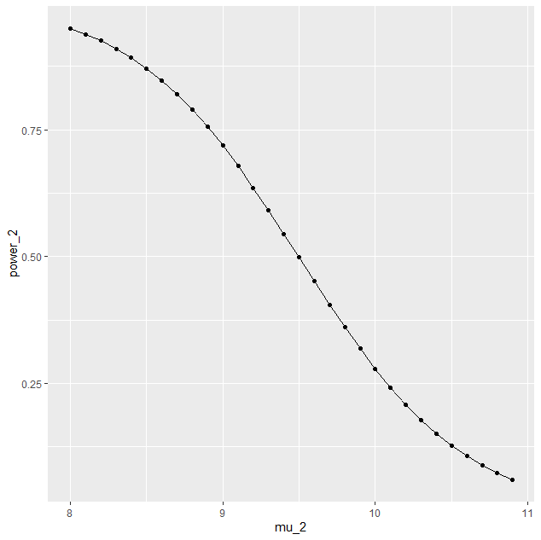

**Power curve generated by using Tableau**

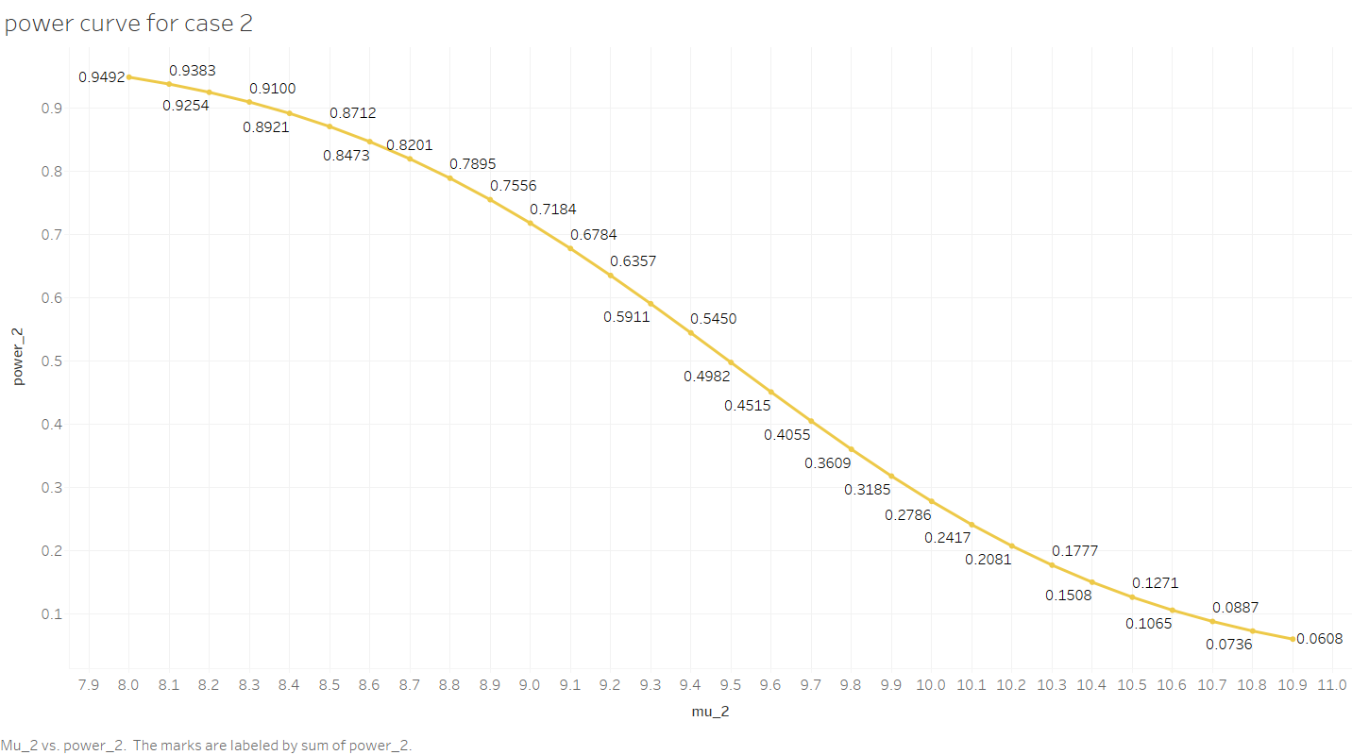

iii) The CR for testing  against  is given by



To find out the value of  and the CR’s , we use the following R-commands

t_tab_3=qt((1-(0.05/2)),11-1)

t_tab_3

t_tab_4=qt((0.05/2),11-1)

t_tab_4

sr_3=11+(sqs*t_tab_3)/(sqrt(n))

sr_3

sr_4=11+(sqs*t_tab_4)/(sqrt(n))

sr_4

 sr_3= 12.8487 and sr_4= 9.151298

The CR is given by



And the power of the test is given by





+

+

Now, to draw the power curve, we construct the following table considering different values of 

**TABLE 3**

|  | **mu_a** | **power_3** |
| --- | --- | --- |
|  |  |  |
| **1** | 11.5 | 0.07647112 |
| **2** | 11.6 | 0.08887098 |
| **3** | 11.7 | 0.10406590 |
| **4** | 11.8 | 0.12226710 |
| **5** | 11.9 | 0.14367027 |
| **6** | 12.0 | 0.16843403 |
| **7** | 12.1 | 0.19665666 |
| **8** | 12.2 | 0.22835288 |
| **9** | 12.3 | 0.26343298 |
| **10** | 12.4 | 0.30168688 |
| **11** | 12.5 | 0.34277583 |
| **12** | 12.6 | 0.38623393 |
| **13** | 12.7 | 0.43148074 |
| **14** | 12.8 | 0.47784477 |
| **15** | 12.9 | 0.52459634 |
| **16** | 13.0 | 0.57098669 |
| **17** | 13.1 | 0.61628922 |
| **18** | 13.2 | 0.65983862 |
| **19** | 13.3 | 0.70106364 |
| **20** | 13.4 | 0.73951068 |
| **21** | 13.5 | 0.77485651 |
| **22** | 13.6 | 0.80691003 |
| **23** | 13.7 | 0.83560448 |
| **24** | 13.8 | 0.86098223 |
| **25** | 13.9 | 0.88317481 |
| **26** | 14.0 | 0.90238097 |
| **27** | 14.1 | 0.91884496 |
| **28** | 14.2 | 0.93283680 |
| **29** | 14.3 | 0.94463556 |
| **30** | 14.4 | 0.95451626 |
| **31** | 8.0 | 0.90238097 |
| **32** | 8.1 | 0.88317481 |
| **33** | 8.2 | 0.86098223 |
| **34** | 8.3 | 0.83560448 |
| **35** | 8.4 | 0.80691003 |
| **36** | 8.5 | 0.77485651 |
| **37** | 8.6 | 0.73951068 |
| **38** | 8.7 | 0.70106364 |
| **39** | 8.8 | 0.65983862 |
| **40** | 8.9 | 0.61628922 |
| **41** | 9.0 | 0.57098669 |
| **42** | 9.1 | 0.52459634 |
| **43** | 9.2 | 0.47784477 |
| **44** | 9.3 | 0.43148074 |
| **45** | 9.4 | 0.38623393 |
| **46** | 9.5 | 0.34277583 |
| **47** | 9.6 | 0.30168688 |
| **48** | 9.7 | 0.26343298 |
| **49** | 9.8 | 0.22835288 |
| **50** | 9.9 | 0.19665666 |
| **51** | 10.0 | 0.16843403 |
| **52** | 10.1 | 0.14367027 |
| **53** | 10.2 | 0.12226710 |
| **54** | 10.3 | 0.10406590 |
| **55** | 10.4 | 0.08887098 |
| **56** | 10.5 | 0.07647112 |
| **57** | 10.6 | 0.06665829 |
| **58** | 10.7 | 0.05924313 |
| **59** | 10.8 | 0.05406694 |
| **60** | 10.9 | 0.05101049 |

**Programming in R for case 3-**

library('ggplot2')

alfa = 0.05

n = 11

t_tab_3=qt((1-(0.05/2)),11-1)

t_tab_3

t_tab_4=qt((0.05/2),11-1)

t_tab_4

#To find out the value of similar region, we use the following R-Program

sv = c(5.2,10.8,7.1,15.4,12.5,12,10.3,10,12.7,9.7,10.5)

variance_sv = var(sv)

variance_sv

sqs = sqrt(variance_sv)

sqs

sr_3=11+(sqs*t_tab_3)/(sqrt(n))

sr_3

sr_4=11+(sqs*t_tab_4)/(sqrt(n))

sr_4

#To find the power curve

n_3 = 11

c = sqs

n_4 = 11

d = sqs

mu_3 = seq(from=11.5, by=0.1, length.out=30)

mu_3

mu_4 = seq(from=8.0, by=0.1, length.out=30)

mu_4

mu_a = c(mu_3,mu_4)

mu_a

power_3 = mat.or.vec(60,1)

for(i in 1:60){

power_3[i] =(1-pt((t_tab_3-(((mu_a[i]-n_3)*sqrt(n))/c)), n-1)) + pt((t_tab_4-(((mu_a[i]-n_4)*sqrt(n))/d)), n-1)

}

power_3

Table = data.frame(mu_a, power_3)

Table

View(Table)

ggplot(data=Table,mapping=aes(x=mu_a,y=power_3))+geom_point()+geom_line()

data.frame(mu_a)

data.frame(power_3)

**Power curve by using ggplot 2**

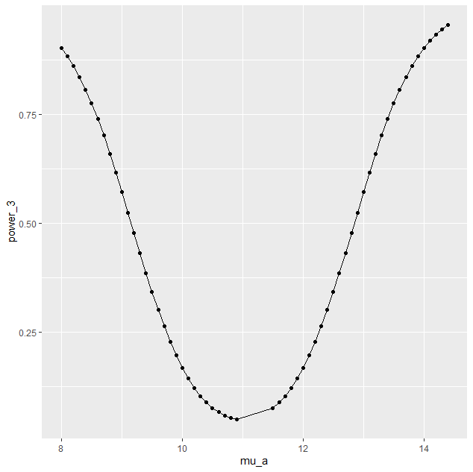

**Power curve generated by using Tableau**

